Game Design Document

Executive summary:
Story: The player is lured into this world by a trick played by an unknown enemy, and he has to navigate through the world believing he is trying to save a friend or family member when in reality it was all a trap to capture him. At the end he must escape and fight this big enemy to escape the world.
World: Medieval, starts in forest/nature. Ends with final boss fight in castle dungeon.
Characters: Main character is dropped into the world, after defeating a mini boss, acquire an AI sidekick that will help you fight enemies. Multiple enemies and bosses will be found throughout the game.
Game mechanics: Kill enemies and bosses while traveling thorough levels, after each kill collect some sort of XP or points to use in the skill tree. Adapt to different weapons and mechanics as you progress through the game. Play with a certain number of hearts for added difficulty.
Beat the game: Fight against one final boss to complete the game. Complete skill tree (for 100% completion).

User interface mock-up:
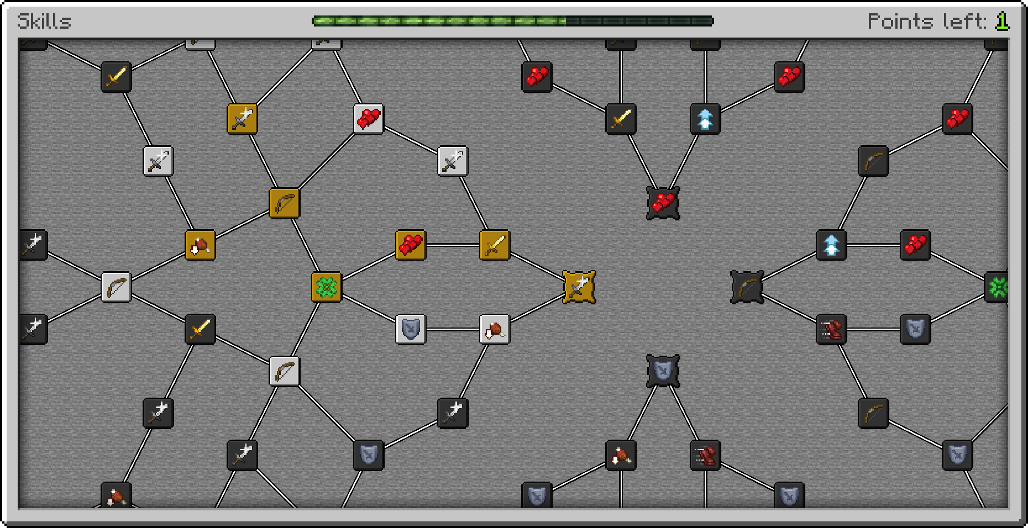
Skill tree:

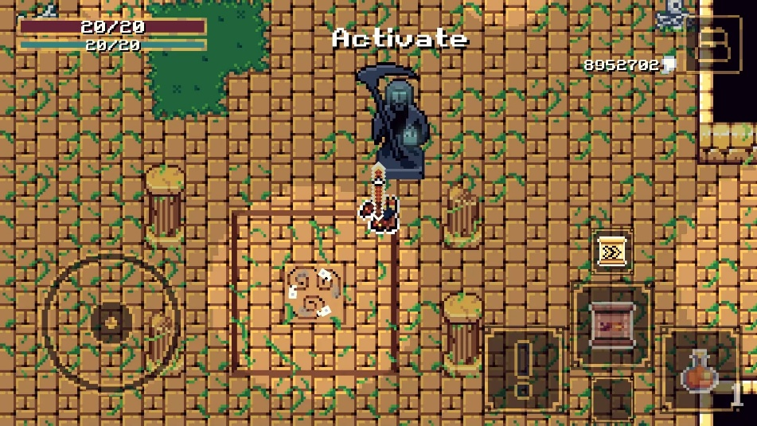
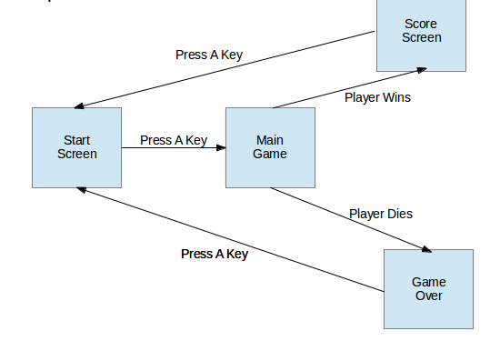
Flow between screens:

Level design:

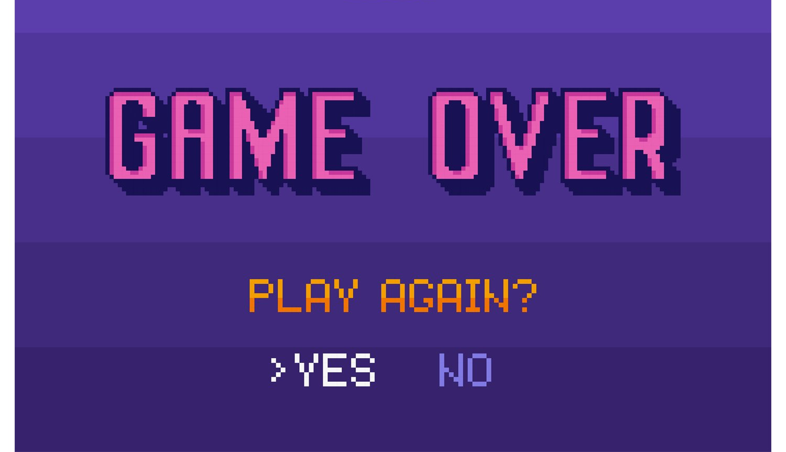
Game over screen:

Game controls:
- Attack : left-click
- Movement : WASD/arrows
- Block : right-click
- Skill tree : Q
- Pause/Main menu : escape

Task and schedule breakdown:
Noah: Level layout design, art. Object animation programming. November 9th.
Jordan: Object programming (player, enemies, bosses, mechanics). November 16th.
Julien: Game world programming (skill tree, point counter). November 9th.
Brandon: GUI programming. Audio design. November 16th.
Deadline: December 11th.

